Associations:
- Active record associations allow us to define relationship b/w models

Types of Associations:
- Rails supports 6 types of associations:
  - belongs_to
  - has_one
  - has_many
  - has_many :through
  - has_one :through
  - has_and_belongs_to_many

belongs_to:
- Sets up a relationship with another model, such that each instance of the declaring model belongs to one instance of the other model
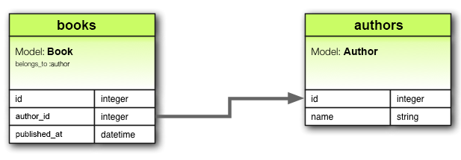
- Eg: Each book can have only one set of Authors
- Eg: belongs_to :author must use only singular term (author) cause if we use plural term it may result in "uninitialized constant Book::Authors" error
- In database terms, the belongs_to association says that this model's table contains a column which represents a reference to another table.
- This can be used to set up one-to-one or one-to-many relations, depending on the setup.
- If the table of the other class contains the reference in a one-to-one relation, then you should use has_one instead.
- When we declare an association the declaring class automatically gains numerous methods related to the association.
Eg:
  - association=(associate)
  - build_association(attributes = {})
  - create_association(attributes = {})
  - create_association!(attributes = {})
  - reload_association
  - reset_association
  - association_changed? #returns true if a new associated object has been assigned
  - association_previously_changed?
- In all of the above methods, association is replaced with the symbol passed as the first argument to belongs_to
- Methods added:
  - association=(associate)
  - build_association(attributes = {})
  - create_association(attributes = {})
  - create_association!(attributes = {})
  - reload_association
  - reset_association

has_one:
- Indicates that one other model has a reference to this model. That model can be fetched through this association.
- The main difference from belongs_to is that the link column (in this case supplier_id) is located in the other table, not the table where the has_one is declared.
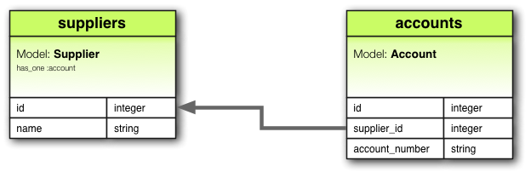
- In database terms, has_one says that the other class contains the foreign key. If this class contains the foreign key, then you should use belongs_to instead.

has_many:
- A has_many association is similar to has_one, but indicates a one-to-many relationship with another model.
- The name of the other model is pluralized when declaring a has_many association
- It is the reverse of belongs_to association and can often be found on the other side of the belongs_to association
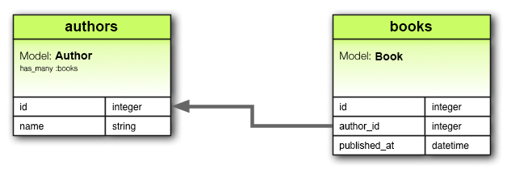
- In database terms, this association says that the other class will have a foreign key that refers to instances of this class.
- This relation can be bi-directional when used in combination with belongs_to on the other model
- Methods added by has_many:
  - collection
  - collection<<(object, ...)
  - collection.delete(object, ...)
  - collection.destroy(object, ...)
  - collection=(objects)
  - collection_singular_ids
  - collection_singular_ids=(ids)
  - collection.clear
  - collection.empty?
  - collection.size
  - collection.find(...)
  - collection.where(...)
  - collection.exists?(...)
  - collection.build(attributes = {})
  - collection.create(attributes = {})
  - collection.create!(attributes = {})
  - collection.reload

has_many :thorugh:
- A has _many :through association is often used to set up a many -to-many relationship with another model.
- This association indicates that the declaring model can be matched with 0 or more instances of another model by proceeding through an intermediate “join” model.
- We call Physician.appointments and Appointment.patient the through and source associations of Physician.patients, respectively.
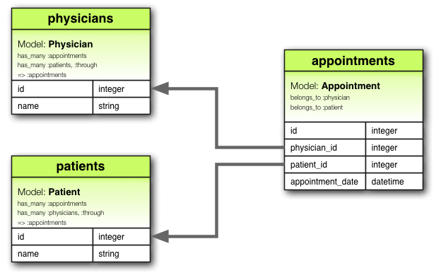
- This is particularly beneficial when you need to access a collection of related records through an intermediary association.

has_one: through:
- A has_one :through association sets up a one-to-one relationship with another model through an intermediary model.
- This association indicated that declaring model can be matched with one instance of another model by proceeding through a third model.
- We call Supplier.account and Account.account_history the through and source associations of Supplier.account_history, respectively.
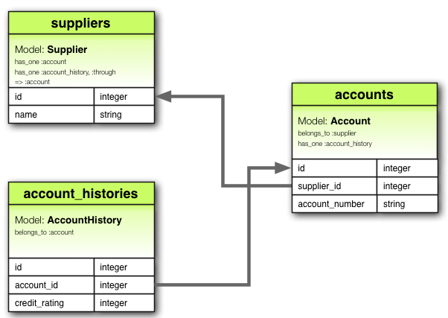

has_and_belongs_to_many:
- It creates a direct many-to-many relationship with another model, with no intervening model
- This association indicates that each instance of the declaring model refers to zero or more instances of another model
- Consider an application with Assembly and Part models, where each assembly can contain many parts, and each part can be used in many assemblies
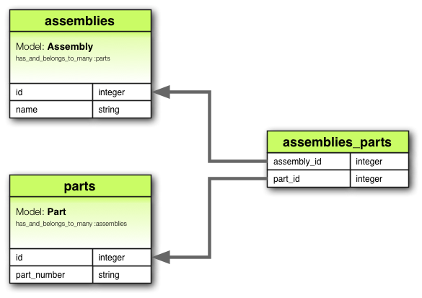
- Even though a has_and_belongs_to_many does not require an intervening model, it does require a separate table to establish the many-to-many relationship between the two models involved.
- Methods by has_and_belongs_to_many:
  - collection
  - collection<<(object, ...)
  - collection.delete(object, ...)
  - collection.destroy(object, ...)
  - collection=(objects)
  - collection_singular_ids
  - collection_singular_ids=(ids)
  - collection.clear
  - collection.empty?
  - collection.size
  - collection.find(...)
  - collection.where(...)
  - collection.exists?(...)
  - collection.build(attributes = {})
  - collection.create(attributes = {})
  - collection.create!(attributes = {})
  - collection.reload

Choosing an Association:

belongs_to vs has_one:
- To set up a one-to-one relationship between 2 models
belongs_to | has_one
- Current Model contains the foreign key | - It owns one instance of the other model
- Current model is a child in the relationship | - Current model is a parent in the relationship

has_many :though vs has_and_belongs_to_many:
- To declare a many-to-many relationship
has_many :through | has_and_belongs_to_many
- Uses intermediary model  (aka join model) | - Does not use an intermediary model (aka join model)
- The join table needs a primary key or a composite primary key | - The join table does not requires a primary key
- Used when there is need to add validations , callbacks and extra attributes | - Used when no additional attributes or behaviours are required,  but can add extra attributes if needed and can be accessed via queries

